**PROGRAM**:

Write the python program for Water Jug Problem

**AIM**: To write a Python program to create water jug problem.

**ALGORITHM:**

STEP1:start the program

Step2:give the required commands for vacuum cleaner

Step3:Initialize two variables ***j1*** and ***j2*** to represent the current amount of water in each jug.

Step4:Set a target amount of water to measure out.

Step5:Create a list of possible actions, including filling a jug, emptying a jug, and pouring water from one jug to the other.

Step6: Create an empty set to keep track of visited states.

Step7:Create a stack to keep track of states to visit, and add the initial state to the stack.

**PROGRAM:**

class VacuumCleaner:

def __init__(self):

self.position = 0 # Position of the vacuum cleaner (0: Left, 1: Right)

self.environment = [0, 0] # Environment with dirty cells (0: Clean, 1: Dirty)

def sense(self):

return self.environment[self.position]

def move(self):

if self.position == 0:

self.position = 1

else:

self.position = 0

def clean(self):

self.environment[self.position] = 0

def run(self, steps):

for _ in range(steps):

current_state = self.sense()

if current_state == 1: # Dirty cell

self.clean()

print(f"Cleaned cell {self.position}")

else:

print(f"Cell {self.position} is already clean.")

self.move()

if __name__ == "__main__":

vacuum_cleaner = VacuumCleaner()

steps = 5

print("Initial environment:", vacuum_cleaner.environment)

vacuum_cleaner.run(steps)

print("Final environment:", vacuum_cleaner.environment)

**OUTPUT:**

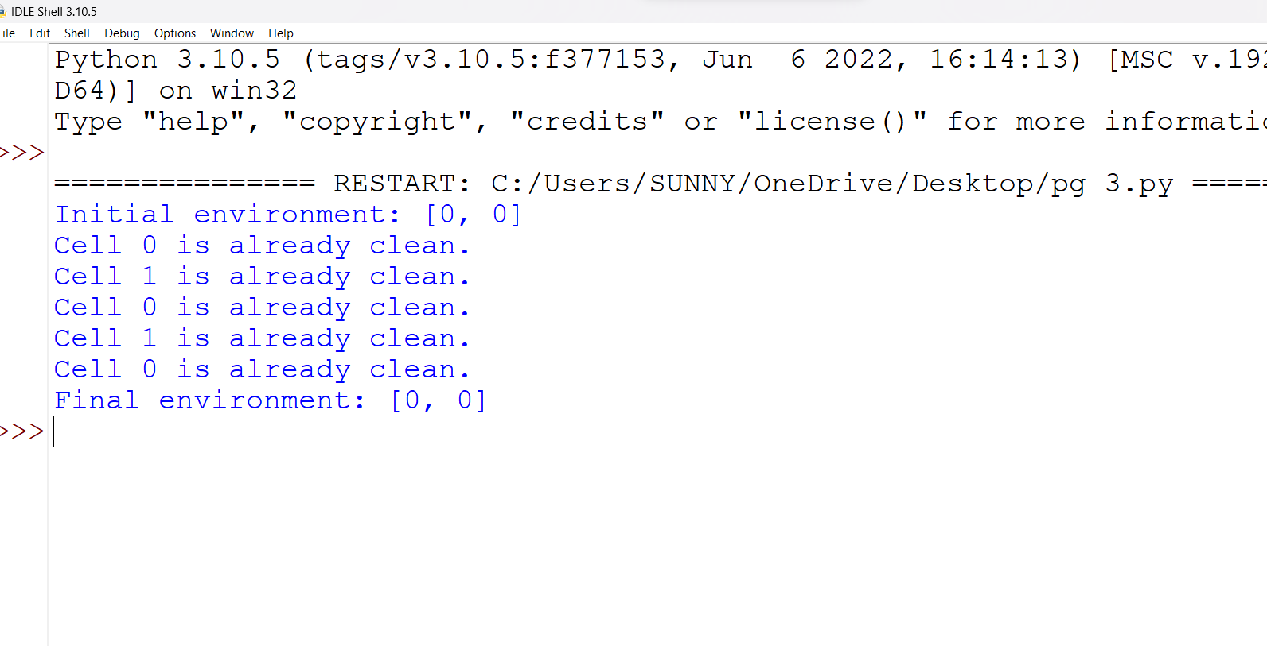

**RESULT:**

The program to execute vacuum cleaner is executed successfully in python